PART 1

1. Trying to print my name with possible errors (Output

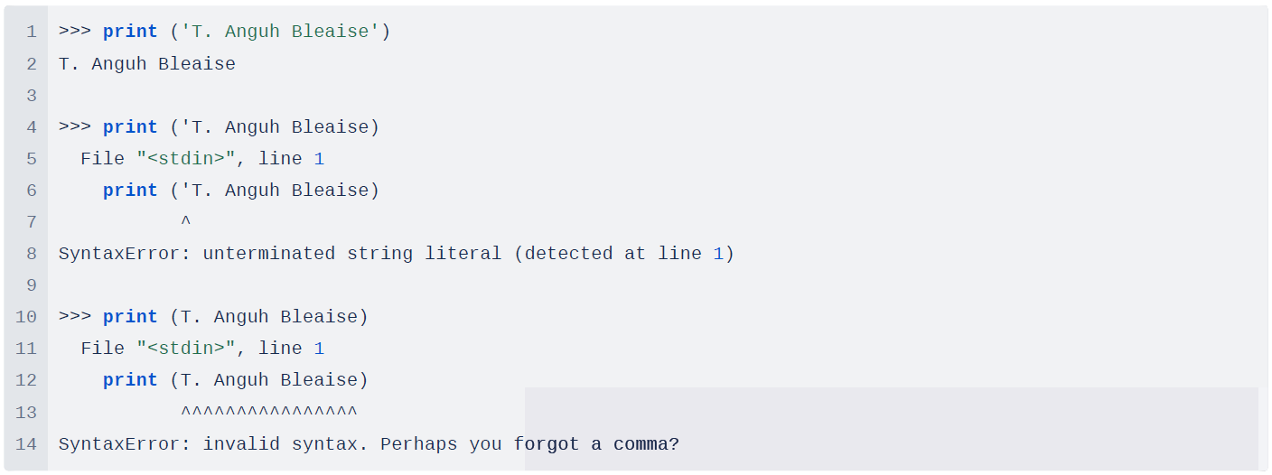

Explanations:

When I try >>> print ('T. Anguh Bleaise), I get an error because printing something like your name will be in the form of a string. In Python, a print statement has to identify the start and the end of a statement. According to the error, Python can tell me that starts with File "<stdin>", line 1 but is unable to find where my string ends which is the missing ending quote. This error SyntaxError: unterminated string literal (detected at line 1) means it is unable to print this statement as a string as it is incomplete.

When I run >>> print (T. Anguh Bleaise), omitting both strings, I get SyntaxError: invalid syntax. Perhaps you forgot a comma? This is not a valid syntax to print a string. It would have been good to print as >>> print ('T. Anguh Bleaise') resulting in T. Anguh Bleaise as shown in the code above.

1. In Python, both the * and ** operators are used for arithmetic operations, but they serve different purposes:
   1. * Operator:
      1. The * operator is used for multiplication.
      2. When used with numbers, it multiplies them together.
      3. When used with sequences like lists or tuples, it performs repetition (concatenation of the sequence with itself a certain number of times).
   2. ** Operator:
      1. The ** operator is used for exponentiation (raising a number to a power).
      2. When used with two numbers, it raises the first number to the power of the second number.

Example output:

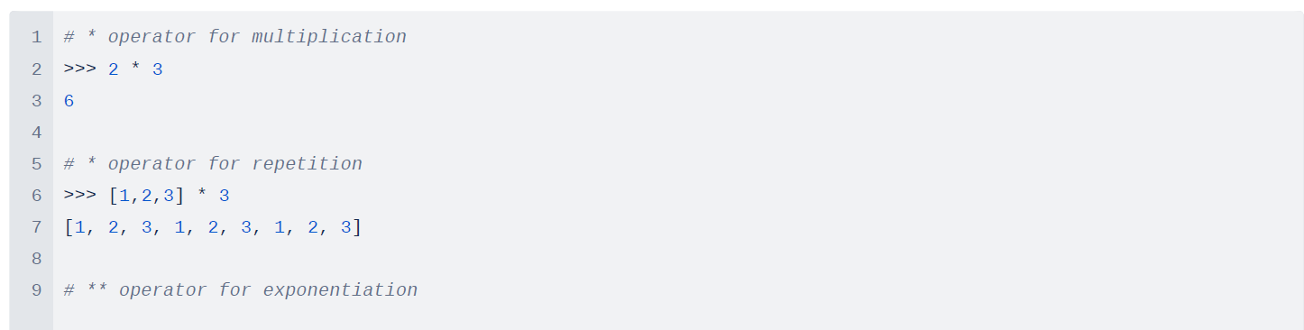



1. 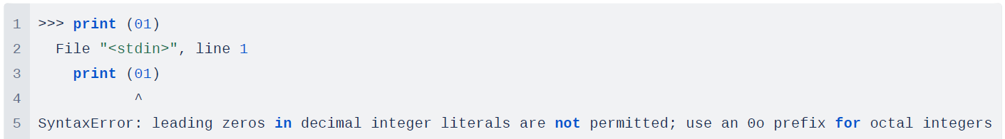In Python, it is not possible to display an integer led by zero (0). e.g., 09, 04, 02, and 01 etc. This is because, in Python, leading zeros in integer literals indicate an octal (base 8) number. However, integers cannot start with a leading zero if the value exceeds 0o7 (octal 7), as this would result in a syntax error as below.

For me, If I need to represent a number with a leading zero for display purposes in Python 3, I can convert it to a string and then display it:



1. Differences between commands type('67') and type(67)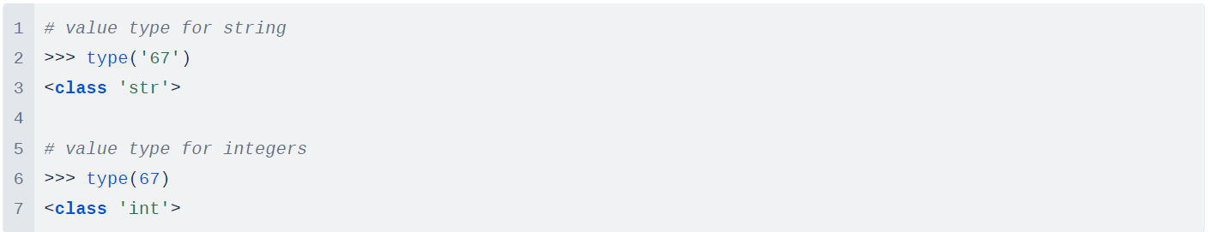

Explanation:

* >>> type('67') . This command checks the type of the string '67'. The output will be <class 'str'>, indicating that '67' is a string data type.
* >>> type(67) . This command checks the type of the integer 67. The output will be <class 'int', indicating that 67 is an integer data type
* The difference in output occurs because '67' is enclosed in single quotes, making it a string literal, while 67 is a numeric literal without quotes, making it an integer. Python treats these as different data types, so it displays different outputs when checking their types.

(Allen Downey, 2015)

**PART 2**

1. Displaying my age multiplied by 2

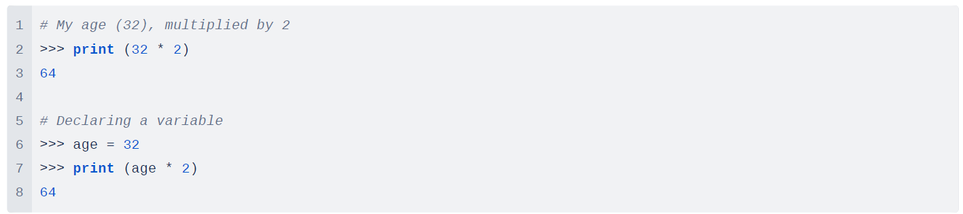

Explanation:

* Input required here are both integers.
* The multiplication operator (*) in Python is used to obtain the result.
* A variable can be declared to hold/store my current age so it can be used elsewhere.
* Results belongs to of type <class 'int'>

1. Displaying the name of the city, country and continent I am living in.

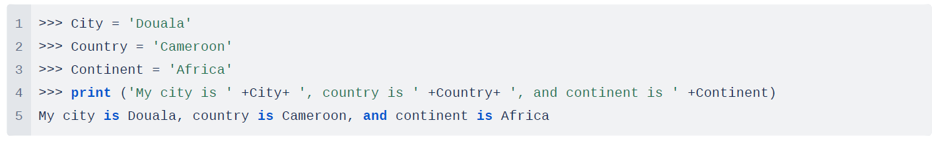

Explanation:

* I declared 3 variables to store my current city, country and continent (Storing it as a string).
* After, I used sting concatenation in Python to display as a sentence.

1. Displaying the examination schedule (i.e., the starting and the ending day) of this term

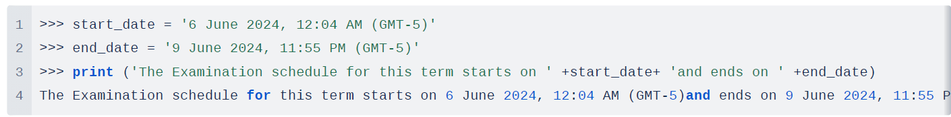

Explanation:

* The start date and end date for the exam schedule are stored in a string variable.
* Print statement is used alongside string concatenation in Python to display the result.

1. Display the temperature of your country on the day the assignment is attempted by you

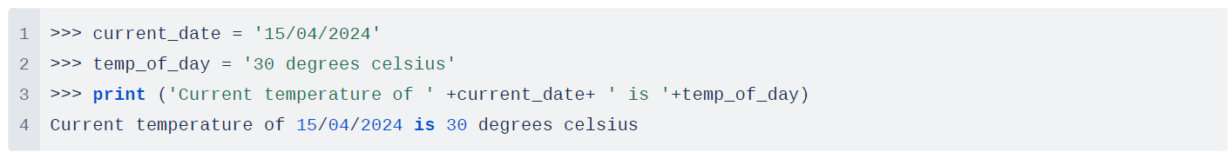

Explanation:

* Current date and end temperature of the day are stored in a string variable.
* Print statement is used alongside string concatenation in Python to display the result.

(Allen Downey, 2015) page 10

**Lessons learned from Part 2:**

1. In Python, variables are used to store data values. Unlike some other programming languages, Python does not require explicit declaration of variables before they are used. When you assign a value to a variable, Python automatically creates the variable and assigns the value to it. They can be reassigned and also help in code debugging.

2. String concatenation can be used in combining multiple strings into a single string. We can use the + operator which is the most common way to concatenate a string.

(Geeksforgeeks, n.d.)